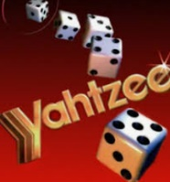
Math Attachment Week # 7
Math Game of the Week- Yahtzee – See Yahtzee attachments for rules, score sheet and dice suggestions

Shopping Spree: You have just received ten brand new $50.00 dollar bills to spend on whatever you wish. Find a weekly flyer or log on to a popular store’s website, make a list of 5 items to purchase that would cost no less than $250.00 and no more than $500.00 before taxes.
Be sure to list the store and make a list of the 5 items along with the prices and the total. Please remember the rules we reviewed last week about how we must line up the decimals when adding and subtracting decimals. HAVE FUN!
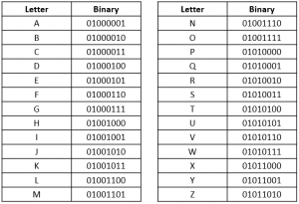
Design and make a BINARY Bracelet:

Math DYI Make a Binary Bracelets
Binary is a base-2 numeric system only using 0s and 1s. It’s the way that data is stored in computers and all words, letters, and symbols can be translated into binary. A bit (or binary digit) contains a single binary number, a 0 or a 1. A byte is 8 binary digits. Large file sizes can contain many bytes. For example, a megabyte contains one million bytes!
All the letters of the alphabet have a binary equivalent:

Gather pipe cleaners and two different colors of pony beads. One color will represent 0s and the other color will represent 1s. String the beads onto the pipe cleaner to represent your first initial. Twist the ends of the pipe cleaner together to make a bracelet. For example, my first initial is “R” and the equivalent byte is 01010010. My bracelet would look like this:

Don’t have pipe cleaners and beads at home? Feel free to use string, macaroni noodles, straw pieces, or whatever you have on hand that resembles beads! You could even draw your Binary code on paper.
You try it:
- Construct the Binary Code for R.V.M.S

R | V | M | S

- Create another Binary code for you first name or another word. Ask someone in your household to solve or another word, post it for one of your classmates to solve.

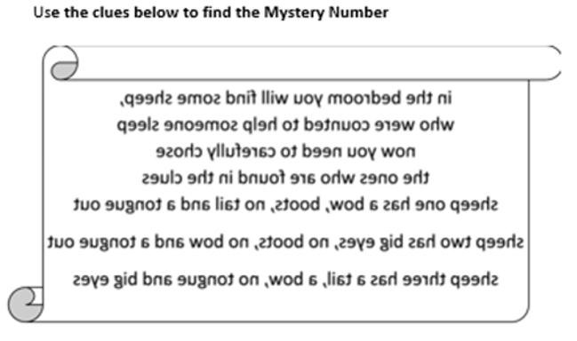
Problem of the Week: Find the Mystery Number “Counting Sheep”

Locate the sheep described above and you will find the mystery number, Good Luck!
